**Set 1**

**Question 5**

Returns on a certain business venture, to the nearest $1,000, are known to follow the following probability distribution

|  |  |
| --- | --- |
| x | P(x) |
| -2,000 | 0.1 |
| -1,000 | 0.1 |
| 0 | 0.2 |
| 1000 | 0.2 |
| 2000 | 0.3 |
| 3000 | 0.1 |

**(ii)** Is the venture likely to be successful? Explain

***Answer)*** Yes, the probability that the venture will make more than 0 or a profit

p(x>0) +p(x>1000) +p(x>2000) +p(x=3000) = 0.2+0.2+0.3+0.1 = 0.8

this states that there is a good 80% chances for this venture to be making a profit.

**(iv)** What is the good measure of the risk involved in a venture of this kind? Compute this measure.

***Answer)*** The good measure of the risk involved in a venture of this kind depends on the Variability in the distribution. Higher Variance means more chances of risk

Var (X) = E(X2) –(E(X))2 = 2800000 – (800)2 = 2160000

**Set 2**

**Question 5**

1. Consider a company that has two different divisions. The annual profits from the two divisions are independent and have distributions Profit1 ~ N(5, 32) and Profit2 ~ N(7, 42) respectively. Both the profits are in $ Million. Answer the following questions about the total profit of the company in Rupees. Assume that $1 = Rs. 45.

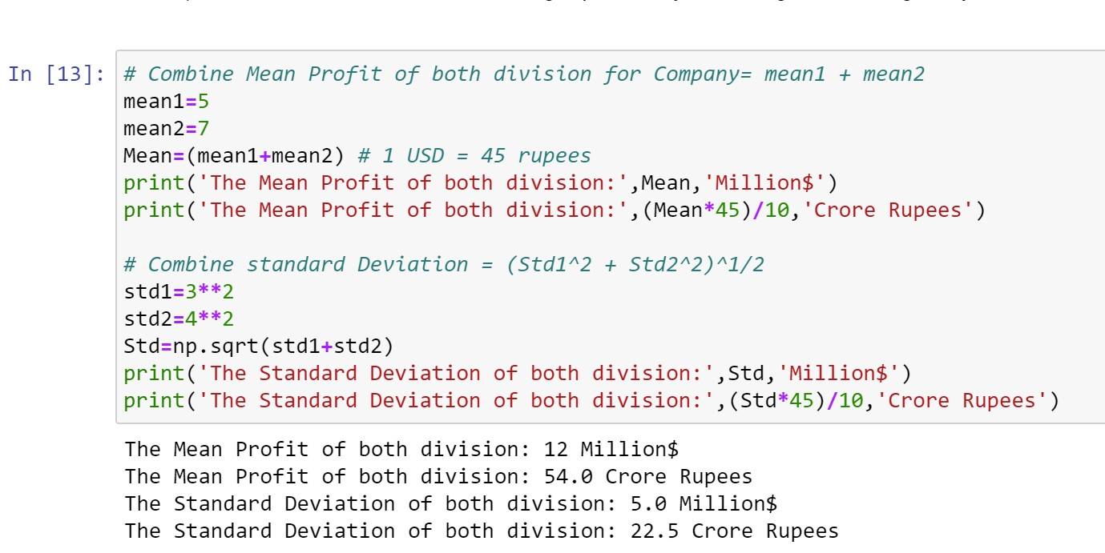

1. Specify a Rupee range (centered on the mean) such that it contains 95% probability for the annual profit of the company.

***Answer)*** Rupee ranges in between [9.9 to 98.1] Crore Rupees, 95% of the time for the Annual Profit of the Company.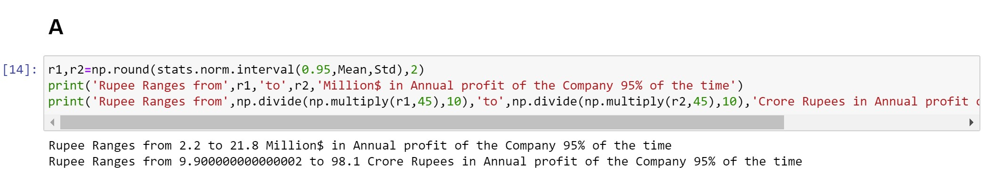

1. Specify the 5th percentile of profit (in Rupees) for the company

***Answer)*** The 5th Percentile of profit for the company is 17 Crore Rupees.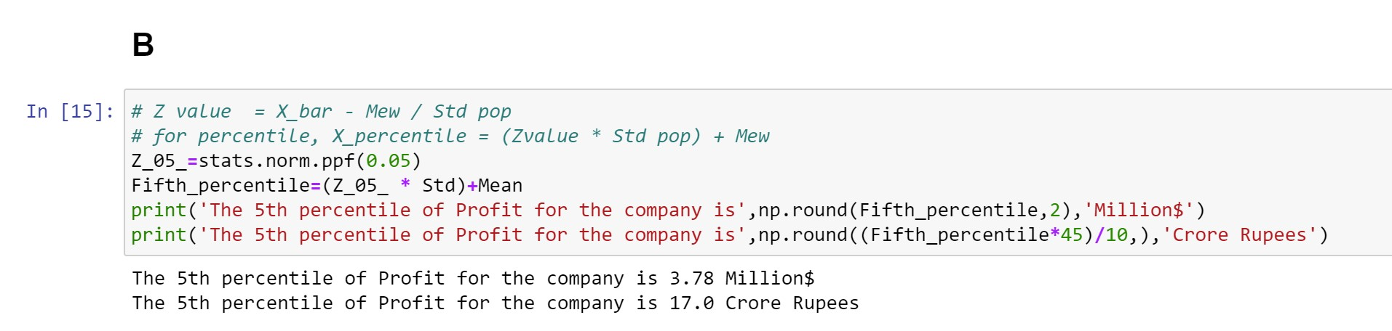

1. Which of the two divisions has a larger probability of making a loss in a given year?

***Answer)*** The Division 2 (Profit2 ~ N (7, 42)) has a larger probability of making a loss in a given year.

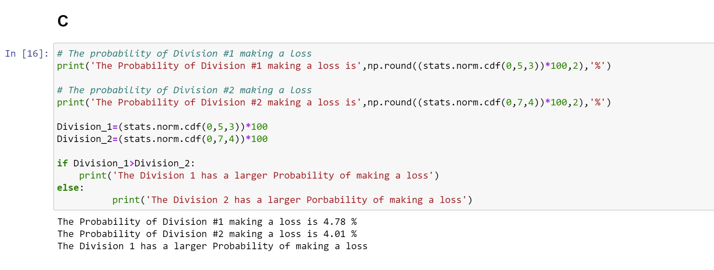

**Set 3**

**Question 1**

For each of the following statements, indicate whether it is True/False. If false, explain why.

**(iii)** Larger surveys convey a more accurate impression of the population than smaller surveys.

***Answer)*** True. Larger surveys provide a more representative sample and reduce sampling bias, increasing the accuracy of the results.

**Question 6**

A book publisher monitors the size of shipments of its textbooks to university bookstores. For a sample of texts used at various schools, the 95% confidence interval for the size of the shipment was 250 ± 45 books. Which, if any, of the following interpretations of this interval are correct?

1. All shipments are between 205 and 295 books.

***Answer)*** Incorrect. The confidence interval provides a range estimate for the population mean, not for individual shipments. It does not guarantee that all shipments fall within that range.

1. 95% of shipments are between 205 and 295 books.

***Answer)*** Correct. In the context of the given confidence interval of 250 ± 45 books, it can be interpreted as follows: We can be 95% confident that the true population mean lies within the range of 205 to 295 books. This implies that if we were to repeatedly sample shipments and construct confidence intervals, approximately 95% of those intervals would contain the true population mean.

1. The procedure that produced this interval generates ranges that hold the population mean for 95% of samples.

***Answer)*** Correct. The procedure used to construct the given confidence interval is based on statistical principles, and in repeated sampling, approximately 95% of intervals generated using this procedure would contain the true population mean. This is the fundamental concept of a confidence interval.

1. If we get another sample, then we can be 95% sure that the mean of this second sample is between 205 and 295.

***Answer)*** Correct. The confidence interval provides a range within which the population mean is estimated to lie with a certain level of confidence. It does not provide information about individual shipments or make claims about all shipments or the population mean.

1. We can be 95% confident that the range 160 to 340 holds the population mean.

***Answer)*** Incorrect. The given confidence interval is 250 ± 45 books, which means the estimated range for the population mean is between 205 and 295 books. It does not support the claim that the range 160 to 340 holds the population mean with 95% confidence.

**Question 7**

Which is shorter: a 95% *z*-interval or a 95% *t*-interval for *μ* if we know that σ =s?

1. The z-interval is shorter
2. The t-interval is shorter
3. Both are equal
4. We cannot say

***Answer)*** The z-interval is shorter.

When the population standard deviation is known and equal to the sample standard deviation, a z-interval can be used for estimating the population mean with greater precision compared to a t-interval. The z-interval relies on the standard normal distribution and does not consider the variability introduced by estimating the population standard deviation from the sample. Therefore, the z-interval tends to be shorter than the t-interval.